Length of a String

Aim
To determine the length of a given string using RAPTOR.

Apparatus Required
- Computer/Laptop
- RAPTOR Software
- Windows Operating System

Procedure
- Open RAPTOR.
- Input a string.
- Use the string length function.
- Store the length.
- Display the length.
- Execute the program.
Flowchart
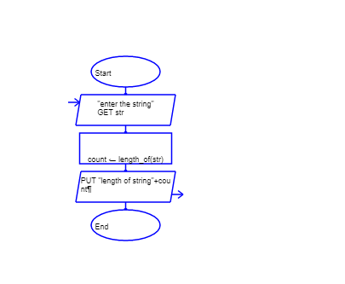
Input
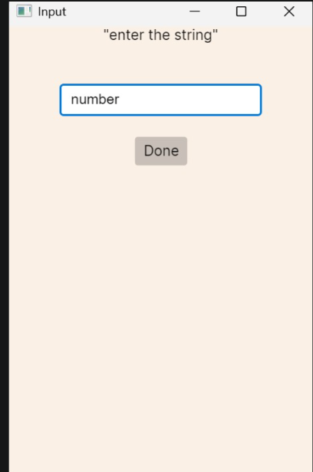
Out put
